**SE401: Software Quality Assurance & Testing**

**Activity 10.1: Web Testing**

**Overview**

In this activity, you will perform testing of a "web" (HTML + JavaScript) application.

**Activity Assignment**

**Selenium test tool installation**

If you have not already done so, install Selenium IDE. Selenium works best with Firefox, though it can be used with other browsers.

To install Selenium, go to [docs.seleniumhq.org/download/](http://docs.seleniumhq.org/download/) and download version 4.1.0 of the Selenium IDE. With Firefox, it will download the plug in and ask you if you wish to install it in Firefox. You will then need to restart Firefox. (<https://addons.mozilla.org/en-US/firefox/addon/selenium-ide/>)

You can run the Calculator application on your Apache local host (e.g., XAMPP).

**Calculator: application to be tested**

The application to be tested has a "web" GUI that looks like this:

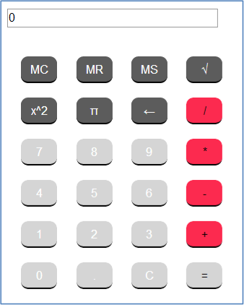

Develop a set of Selenium regression test for it, being as thorough as necessary to properly test the program. Save your test suite to an HTML file named *calctest.html*, using the Firefox/Selenium **File->Save Test Case** menu command that is available when the Selenium IDE window is selected.

**Applying regression testing**

Next, download the calculator application. Unzip the folder to a local directory, and run the application in Firefox. Execute your Selenium tests. If you identify any failures, fix the code in the JavaScript/HTML files, and re-run your test suite. As you make fixes, put comments in the corrected code explaining what you changed.

Prepare a **PDF** report on your activity experience, including:

* Your name and assignment identification
* A description of how you prepared and executed the tests.
* The listing of your test case(s), as saved in *calctest.html*.
* A listing of any defects you found and fixed in the software under test.
* Your description of the activity experience and any remaining questions that you have.
* The location of your final test case(s) and source code

If you have any questions, consult the instructor.